# Homework: Semantic HTML, Frames, Other Tags

This document defines homework assignments from the [“Web Fundamentals (HTML & CSS)“ Course @ SoftUni](https://softuni.bg/courses/web-fundamentals/). Please submit as homework a single zip / 7z archive holding the source code of all below described problems.

## Write Semantic HTML

Use Semantic HTML to create an HTML page. You’ll be given two files - **text.txt** and **problem1.png**. Use the provided text and create a page that looks like the image in **problem1.png**. **Do not apply styles**.

## Some Other Semantic Tags

Create a HTML page like the image below. Use **meter, figure, figcaption, audio, video, embed, source, track tags**.

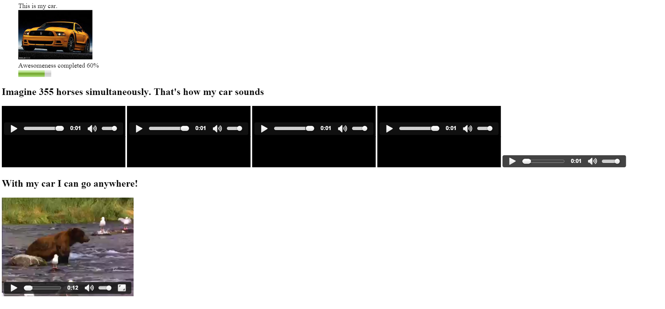

Here some resources you can use:

<http://www.w3schools.com/tags/horse.ogg>

<http://www.w3schools.com/tags/movie.mp4>

<http://www.w3schools.com/tags/movie.ogg>

## *Kent’s Media Profile

Create an HTML page like the image below (100% accuracy is not required). Use **CSS, meter, figure, figcaption, audio, video, embed, source, track tags.**



## *JavaScript Worship

Create a HTML page like the image below. Use canvas and JavaScript. **100% accuracy IS required.**

